**Automatic Refilling System**

By:

Dikshant Yesankar (Roll no 21, SEC B, SEM IV)

Vinay Katariya (Roll no 80, SEC B, SEM IV)

Vipul Jain (Roll no 81, SEC B, SEM IV)

Vivek Kaushik (Roll no 82, SEC B, SEM IV)

**SESSION- 2020-2021**

**ANALOG CIRCUIT TA PROJECT ECT257**



**Shri Ramdeobaba College of Engineering and Management**

(DEPARTMENT OF ELCTRONICS AND COMMUNICATION ENGINEERING)

**Contents: Pg.no**.

|  |  |
| --- | --- |
| Abstract | 2 |
| Component List and description | 2 |
| Flow chart of Operation | 3 |
| Block and Circuit diagram | 4 |
| Working | 5 |
| Result | 6 |
| Advantages and disadvantages | 7 |
| Conclusion | 7 |

**Abstract:**

In many houses there is unnecessary wastage of water due to overflow in Overhead Tanks. Automatic Tank Refilling System can provide a solution to this problem. As the water level rises or falls, different circuits in the controller send different signals. These signals are used to switch ON or switch OFF the motor pump as per our requirements. So, the main objective of this project is to design and develop an automatic tank refilling system to maintain the outlet process of the water level at its desired level.

**Components List and Description:**

|  |  |  |  |
| --- | --- | --- | --- |
| **COMPONENTS** | **SPECIFICATION** | **QUANTITY** | **DESCRIPTION** |
| * IC555 | Bipolar NE555 | 1 | Here, we use the 555 timer as a flip-flop element i.e. in bi-stable mode. |
| * Transistor (Q1) | BC547A | 1 | Used as a switch |
| * Capacitor (C1) | 0.01 µF | 1 | Used to reduce ripples and noise |
| * Diode (D1) | 1N4007 | 1 | Used to pass the current in one direction |
| * LED (1,2,3) | 3-5 V | 3 | Used to indicate   * Power supply * The ON/OFF state of the Pump. |
| * Resistors | R1 = 200Ω; R2=1kΩ; R3=R6=R710kΩ; R4=R5=1MΩ | 7 | Resistors used to reduce current flow and lower voltage levels within circuits |
| * Power Supply (VCC) | (VCC) = 12 Volts | 1 | **-** |
| * Switches (S1, S2)- Metallic Contacts | L-shaped metallic contact | 2 | Aluminium contacts which conduct electricity when the space between them is bridged by water |

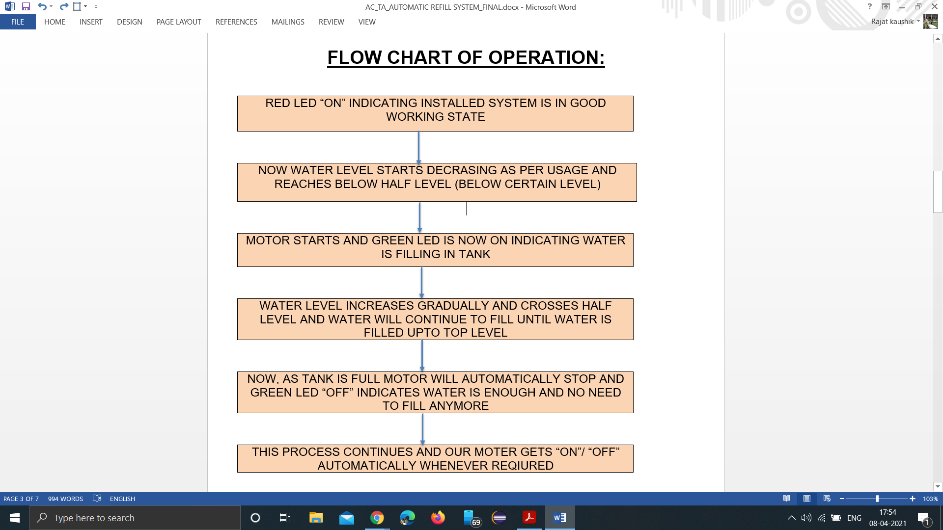**FLOW CHART OF OPERATION:**

**BLOCK DIAGRAM:**

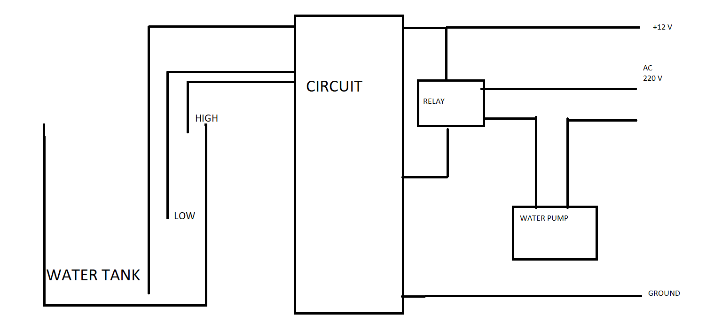

**CIRCUIT DIAGRAM:**

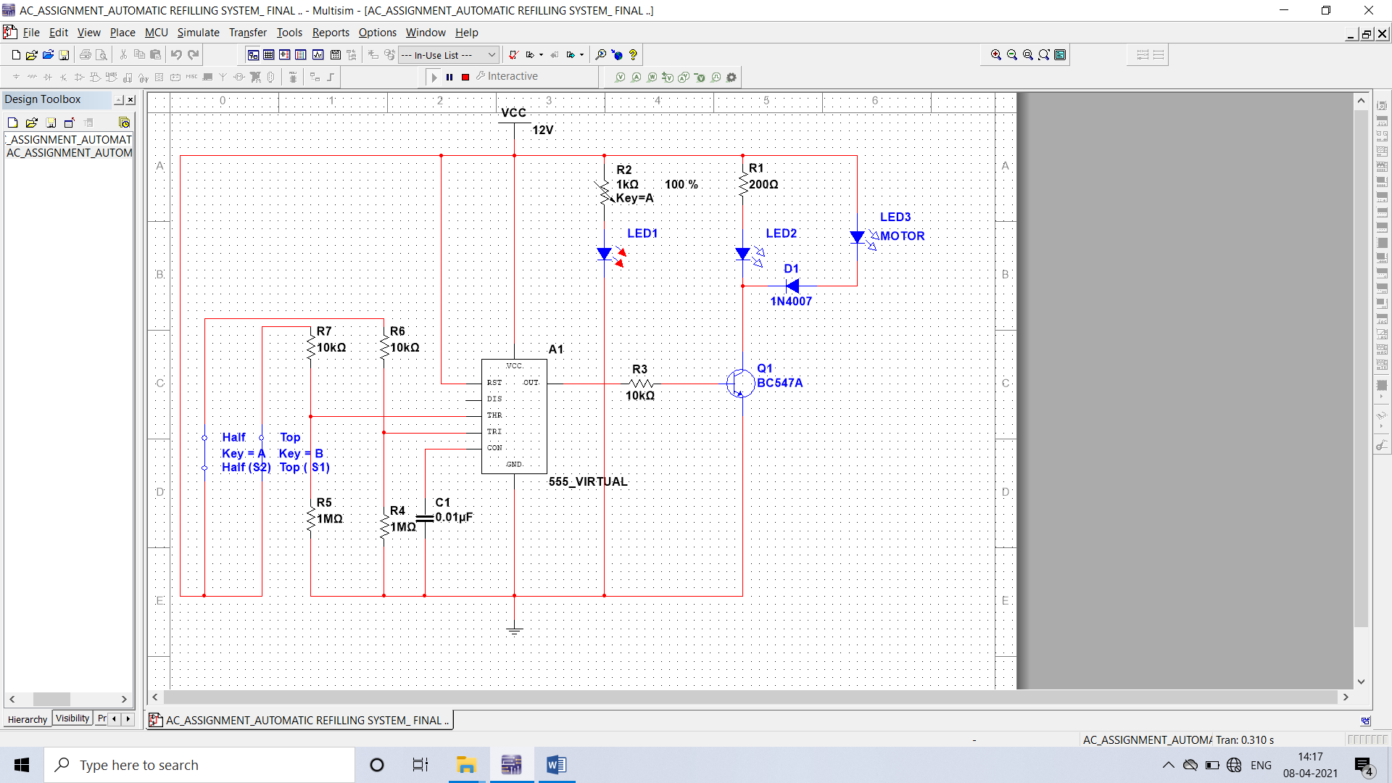

(Above image, when tank is filled and motor is OFF)

**WORKING:**

Considering 1st condition when water is at top level so:

Switch S1 (Top level) is at high voltage (VCC) then through comparator C1 inside timer IC the output will be high i.e. S= HIGH. And since switch S2 (Half level) is also at high level then the output of comparator C2 will be low i.e. R = LOW. Therefore, output of SR flip-flop will be Q = HIGH, Q (bar) =LOW. And thus, output pin of IC 555 will show output as LOW. Similarly output pin of IC 555 will show output as LOW when water is between half and top, and output pin will be HIGH when water is below half level.

|  |  |  |  |  |
| --- | --- | --- | --- | --- |
| **WATER LEVEL** | **SENSOR**  **(SWITCH)** | **STATE OF SWITCH** | **IC 555 OUTPUT PIN** | **MOTOR**  **(LED3)** |
| TOP | S1 | HIGH | LOW | OFF |
| S2 | HIGH |
| BETWEEN  TOP AND HALF | S1 | LOW | LOW | OFF |
| S2 | HIGH |
| BELOW HALF | S1 | LOW | HIGH | ON |
| S2 | LOW |

Since output pin of IC 555 is LOW when tank is full, the transistor Q1 will be in cut off region and will act as an OFF switch. Then by attaching multimeter across transistor we got output voltage across equal to 11.005V.

Now as the junction potential between diode D1 and LED D2 was found to be 11V and here we have our Vcc of 12V which is directly connected to resistor R1 and since the voltage difference is very low between Vcc and junction potential and also a resistance value R1=200 Ω which is in a intermediate range, therefore current through LED 2 will be very low and diode LED 2 will act in reverse biased condition. Therefore, current through diode D1 and Motor (LED 3) will also be very less, thus LED 3 will also be in OFF state and water will not fill. Similarly, when water is below half level and needs to be refilled, the output pin will give High voltage and current LED 2 and Motor (LED 3) will turn ON and thus our tank gets refilled automatically.

**RESULT:**

The automatic water refilling system has been successfully designed and developed. The motor is turned “OFF” and “ON” according to the water levels. Compared to other conventional methods, the automatic water level controller shows excellent performance with its reliable technology and it is cheaper and durable.

The experimental model on multisim was made according to the circuit diagram and the results were as expected. The motor is switched ON when the overhead tank was about to go dry and switched OFF when the same was about to overflow.

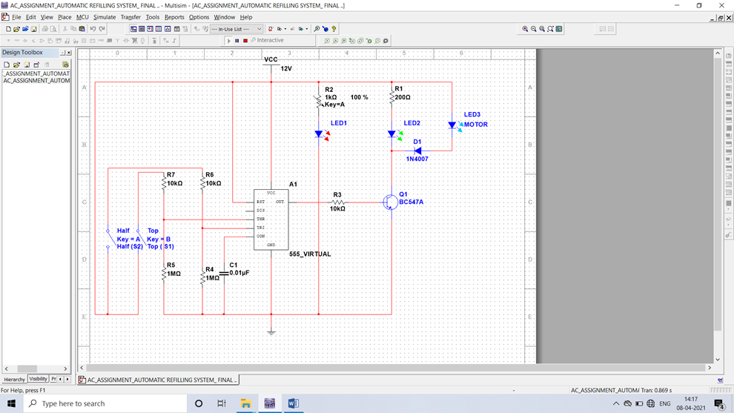

(Above image, when tank is empty and motor is on)

**ADVANTAGES:**

1) Automatic water level controller is used to automatically fill the overhead tank as and when it gets empty and monitor the level in it.

2) It has low maintenance.

3) It avoids the seepage of walls and roofs when the tank overflows.

4) Automatic refilling system's precise working saves both water and motor energy (electricity).

**DISADVANTAGES:**

1. It is a passive electrical system and hence it requires continuous power supply

**Conclusion:**

Water level controller is a simple yet effective way to prevent wastage of water. Its simplicity in design and low-cost components make it an ideal piece of technology for the common Man. Thus, the automatic water level controller is a big boon as concerned with the house hold applications as well as other water saving purposes including agricultural sector and industries. Based on the survey result, it is found that the automatic water level controller has a rising demand and it is a good asset from the electronics perspective.

